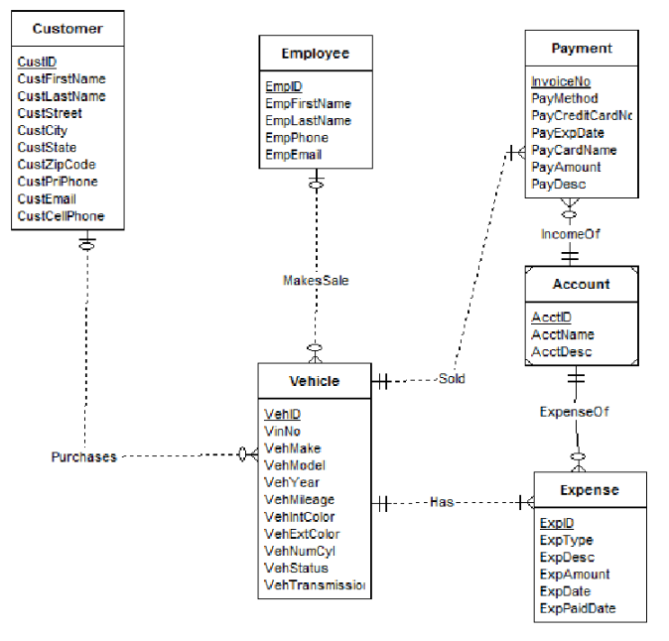

Errors:

1. Vehicle Entity requires additional attribute ‘Transmission type’.
2. Customer entity requires both primary phone and cell phone number attributes.
3. Purchases relationship should not have a mandatory customer (should be an oval notation) as the narrative indicates vehicles may not be sold for a while.
4. MakesSale relationship should also not have a mandatory employee (should be oval notation) because vehicles tend not to be sold instantly.
5. In ExpenseOf relationship the connection to Expense entity should be multiple and optional and the connection to Account should be mandatory and single.
6. IncomeOf relationship should correspond to a single, mandatory account since the Account entity is a weak entity.
7. The Process relationship is redundant: any employee can be connected indirectly via the Vehicle and Payment entities.